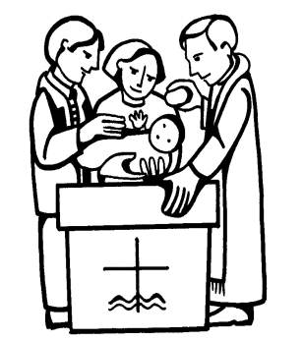
Upper Creggan Parish
Baptismal Booking Form

St. Patrick’s 1st & 3rd Sat @ 5.00pm
St. Brigid’s, Glassdrummond, 2nd Saturday @ 6.00pm
Sacred Heart, Last Sunday after 11am Mass

Name of Child _____________________________________________
(must match civil register)

Date of birth ______________________________________________

Father’s name: ______________________________________________

Mother’s maiden name ___________________________________________
(including first name)

Parent’s Address ______________________________________________

______________________________________________

______________________________________________

Telephone ______________________________________________

Church & Year of Marriage ________________________________________

(Sponsors must be 16 years of age and have been confirmed.)

Sponsors ______________________________________________

______________________________________________

Proposed Date of Baptism ________________________________________

Place of Baptism ______________________________________________

First time Parents must attend a short one evening procedure on Baptism.
Is this your first child ____________________________________________

This form (available online) must be returned in person to the parish office where the booking will be confirmed.

Baptised by _____________________________________ Date. _______

